**First assignment of c programing .**

**Student Name : مازن طارق محمد مغورى**

**Id : 18011318**

**Section or lab : 5**

**Electrical power engineering.**

**Code 1:**

#include <stdio.h>

#include <stdlib.h>

int main()

{

float x,y,z ;

printf("please enter the first number \n");

scanf("%f",&x);

printf("please enter the second number \n");

scanf("%f",&y);

z=x+y;

printf("x+y=%f \n",z);

z=x-y;

printf("x-y=%f \n",z);

z=x*y;

printf("x*y=%f \n",z);

z=x/y;

printf("x/y=%f \n",z);

z= (x+y)/2;

printf("(x+y)/2=%f \n",z);

z = (int) x % (int) y;

printf("x%%y=%f\n",z);

return 0;

}

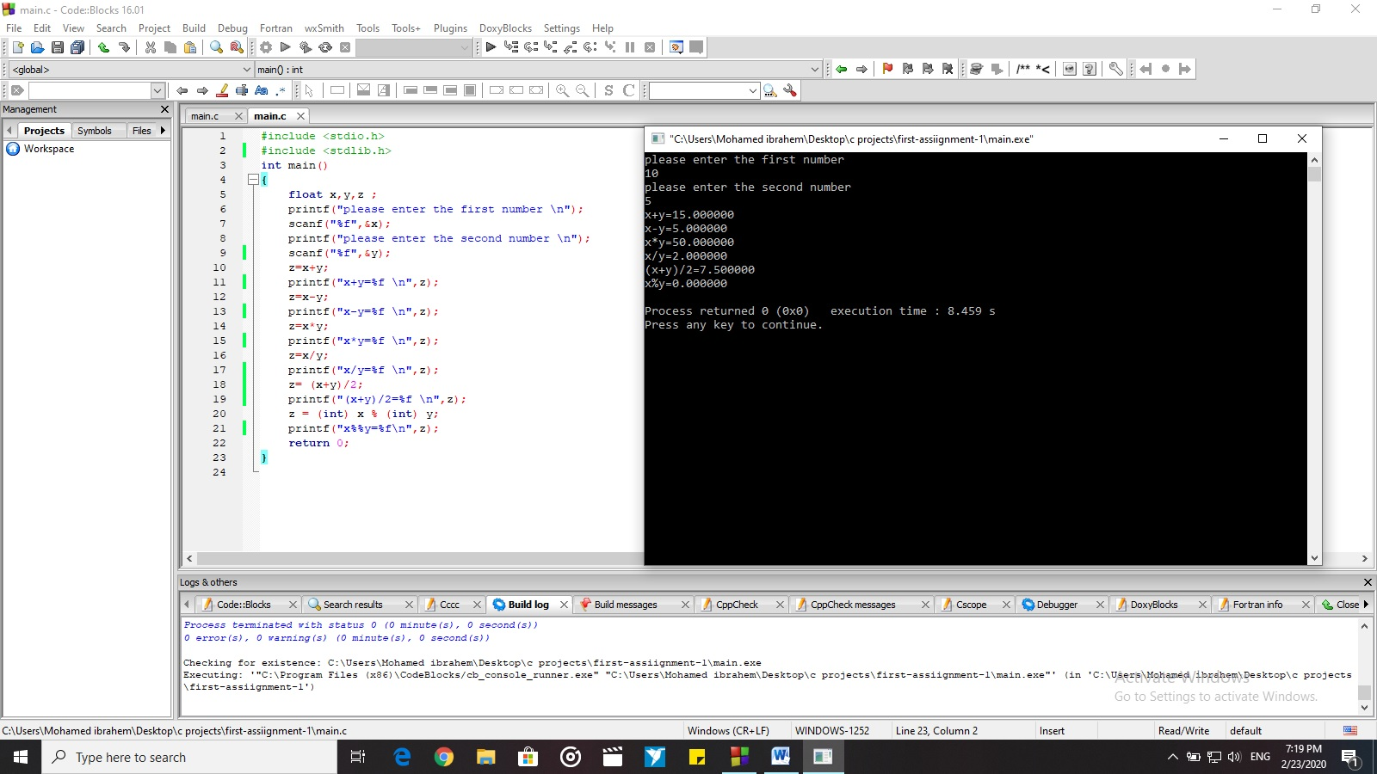

**Code 2:**

#include <stdio.h>

#include <stdlib.h>

int main()

{

int x,y,z;

printf("enter first binary number \n");

scanf("%x",&x);

printf("enter second binary number \n");

scanf("%x",&y);

z=x&y;

printf(" x and y =%x\n",z);

z=x|y;

printf(" x or y = %x\n",z);

z=x^y;

printf(" x xor y = %x\n",z);

z=!x;

printf(" not x= %x\n",z);

z=!y;

printf(" not y = %x\n",z);

//---------------------

int f,h,j;

printf("enter first hexa number number \n");

scanf("%x",&f);

printf("enter second hexa number number \n");

scanf("%x",&h);

f=h&j;

printf("h and j = %x\n",f);

f=h|j;

printf("h or j = %x\n",f);

f=h^j;

printf("h xor j = %x\n",f);

f=!h;

printf("not h = %x\n",f);

f=!j;

printf("not j = %x\n",f);

return 0;

}

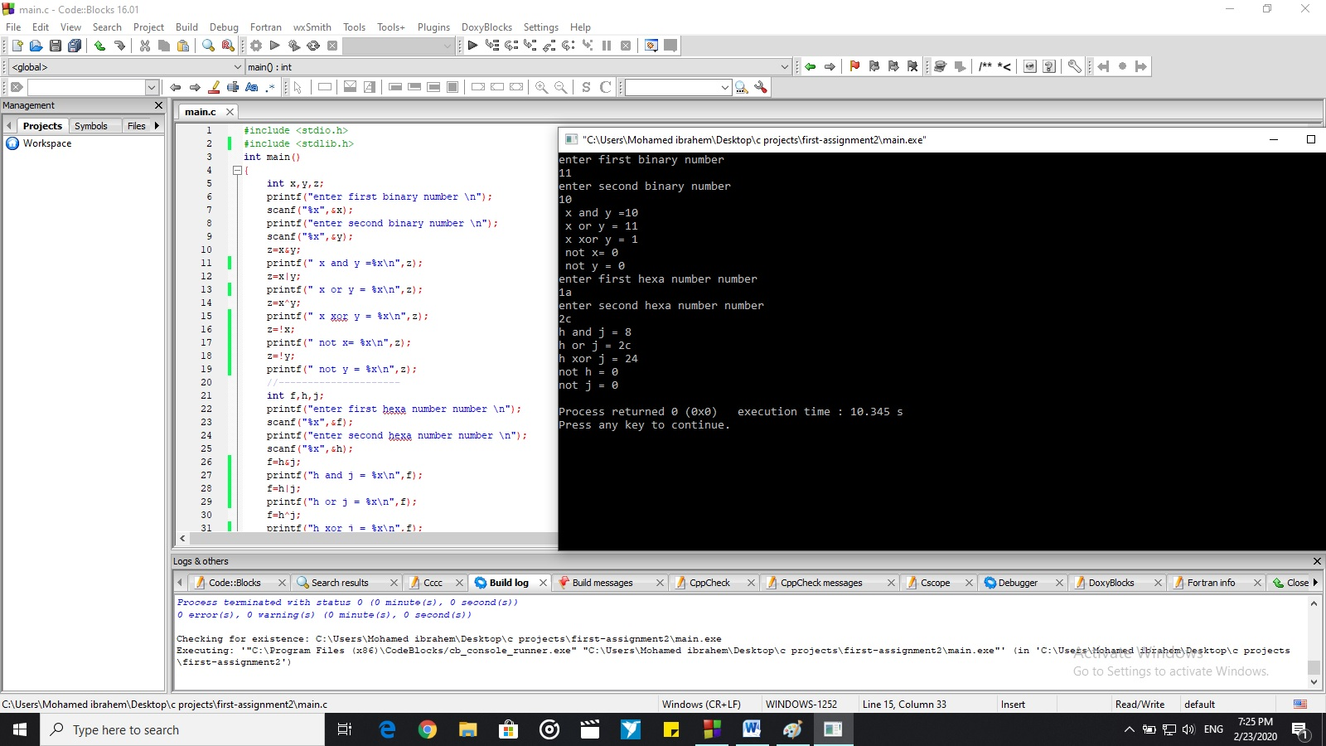

**Code 3:-**

#include <stdio.h>

#include <stdlib.h>

int main()

{

//circumstance == المحيط == c

float d , l , w , m , area2 , area3 , c2 , c3 ;

float area1 , c1 ;

const float pi =3.14;

// circle area and circumstance .

printf ("first of all we will get the area and the circumstance of the circle. \n");

printf("so please enter the circle diameter \n");

scanf("%f",&d);

area1= pi*d*(d/4);

printf("circle area =%f \n",area1);

c1= pi * d;

printf("circle circumstance =%f \n",c1);

// Rectangular area and circumstance .

printf("now we will get Rectangular area and circumstance.\n");

printf("so please enter the Rectangular length \n");

scanf("%f",&l);

printf("now please enter the Rectangular width \n");

scanf("%f",&w);

area2=l*w;

printf("Rectangular area =%f \n",area2);

c2= (l+w)*2;

printf("Rectangular circumstance =%f \n",c2);

// Square area and circumstance .

printf("now we will get Square area and circumstance.\n");

printf("so please enter the length of one branch in the Square \n");

scanf("%f",&m);

area3=m*m;

printf("Square area =%f \n",area3);

c3= m*4;

printf("Square circumstance =%f \n",c3);

return 0;

}

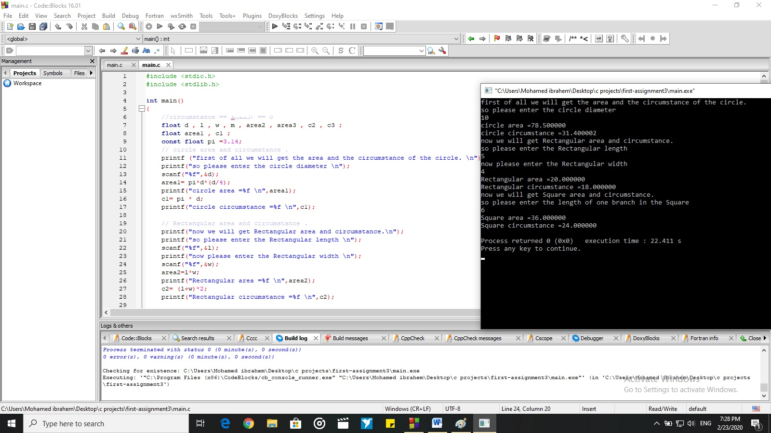

**Code 4:-**

#include <stdio.h>

#include <stdlib.h>

int main()

{

float price , total_price , tax , total_tax;

const float tips = 0.03 ;

const float service = 0.04 ;

printf("please enter the meal price \n");

scanf("%f",&price);

printf("please enter the tax \n");

scanf("%f",&tax);

total_tax= tax * price *0.01 ;

printf("total_tax=%f \n",total_tax);

total_price= total_tax + price + tips*price + service * price ;

printf("total_price=%f\n",total_price);

return 0;

}

